RSB Marketing Materials Request Form

If you would like to request some Royal Society of Biology (RSB) marketing materials for your event, please complete all sections of the form below and return in no less than 10 working days before your event (otherwise we cannot guarantee arrival in time). Please note that materials requests are subject to stock.

We kindly request that you do not order more than you require for your event. We do our best to use online formats for sharing information to reduce the environmental cost of printing. If there are any materials left over after your event, please do keep them for future use.

Send your completed form and direct any queries to membership@rsb.org.uk

Your name:
Email address:
Contact number:
Shipping address:
Including postcode
What date do you require the materials by?
Your affiliation to the RSB:
E.g. Branch member, Ambassador, RSB BioSoc
If this is for a branch event, which branch are you a member of?
Event name:
Event date:
Event url:
Number of expected attendees:

Stickers (1 sheet x 35 I heart biology stickers) | Number of sheets:
RSB branded pencils  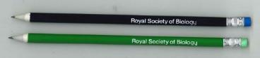 | Quantity:
Membership grades and prices  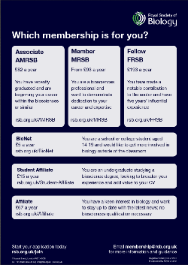 | A4 leaflet quantity:  Digital version required? Yes/No
Membership for professionals | A4 leaflet quantity:  Digital version required? Yes/No
Membership for teachers | A4 leaflet quantity:  Digital version required? Yes/No
Membership for technical staff | A4 leaflet quantity:  Digital version required? Yes/No
Organisational membership (MO) | A4 leaflet quantity:  Digital version required? Yes/No
Undergraduate student membership | A4 leaflet quantity:  Digital version required? Yes/No
Schools and colleges (SCAS) membership | A4 leaflet quantity:  Digital version required? Yes/No
Membership for graduates/early career | A4 leaflet quantity:  Digital version required? Yes/No
Membership for 14-19 year olds (BioNet) | A4 leaflet quantity:  Digital version required? Yes/No

